Monthly Report /#1

- Date of Report: 3/8/2025
- Student ID - Name: 21110241 Issam Awamleh
- Major: Cybersecurity
- Company: CyberShield Academy - JODDB
- Department: Cybersecurity
- Industry Mentor: Alaa Atoum
- Apprenticeship Mentor: Shareef Shargawi
- Working days/hours: 8/8:30-4/4:30 Sunday–Thursday
Your report must cover these topics:
- Your role and responsibilities this month (+ evidence)
- I am cybers security trainee, so my responsibility to help them getting the tasks done that assigned to me in different branches of cyber security such as SIEM solution also dealing with firewall and VPN and so many more
- I was responsible also for my individual development by attending upskilling courses and self learn with CPTS (certified penetration testing specialist ) in Hack the box.
Evidances:

My tasks that Assigned for me
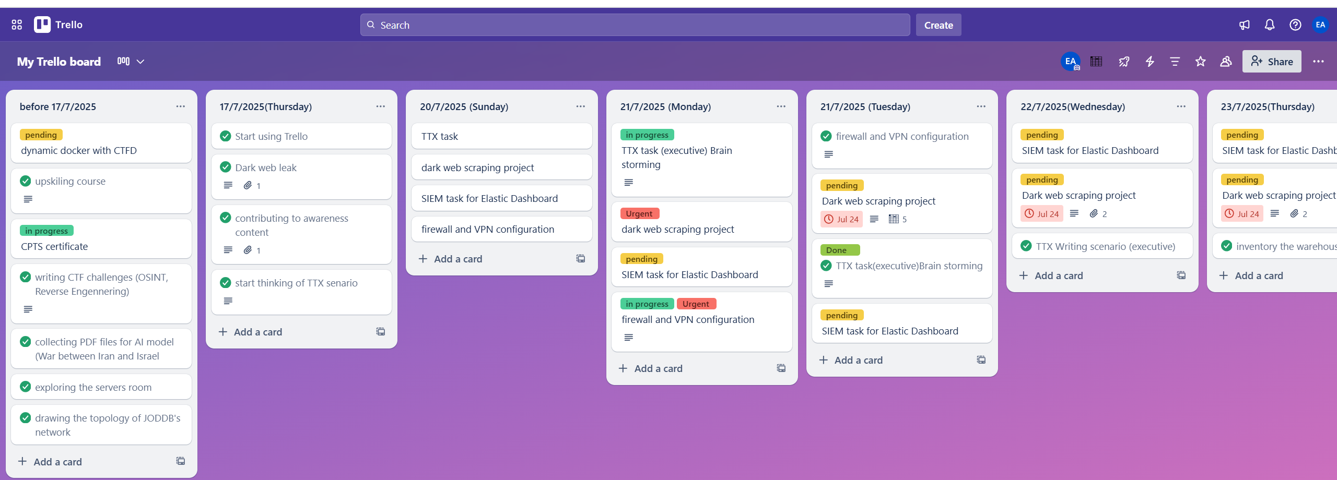

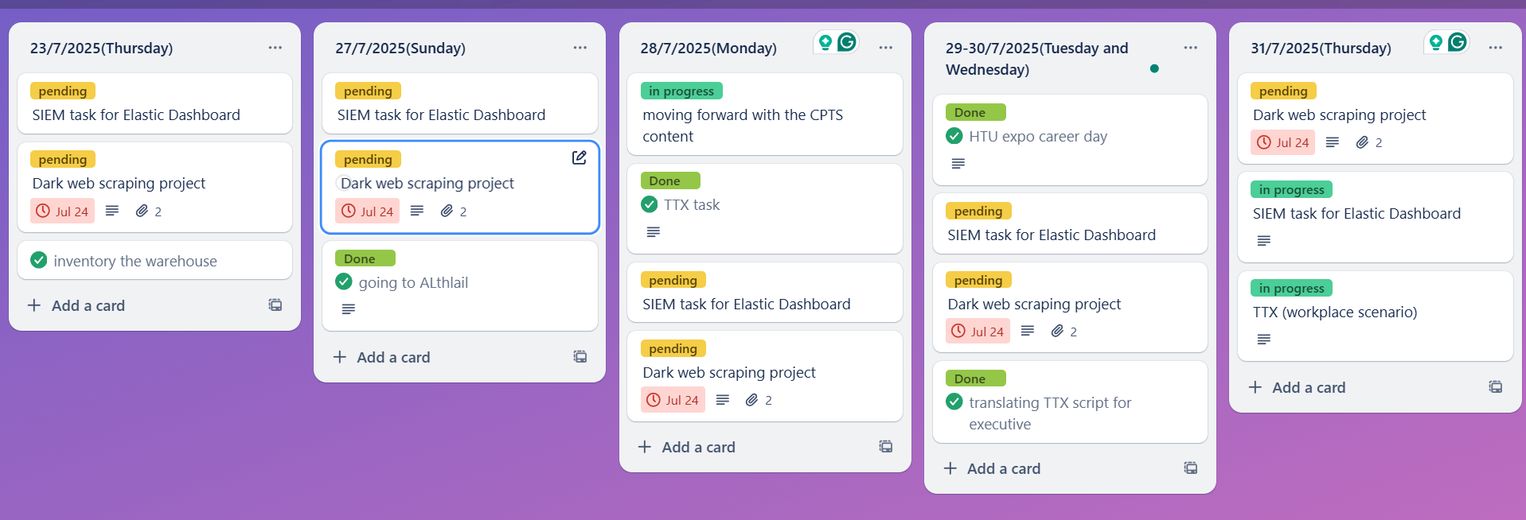
All the tasks getting from Click up for all:
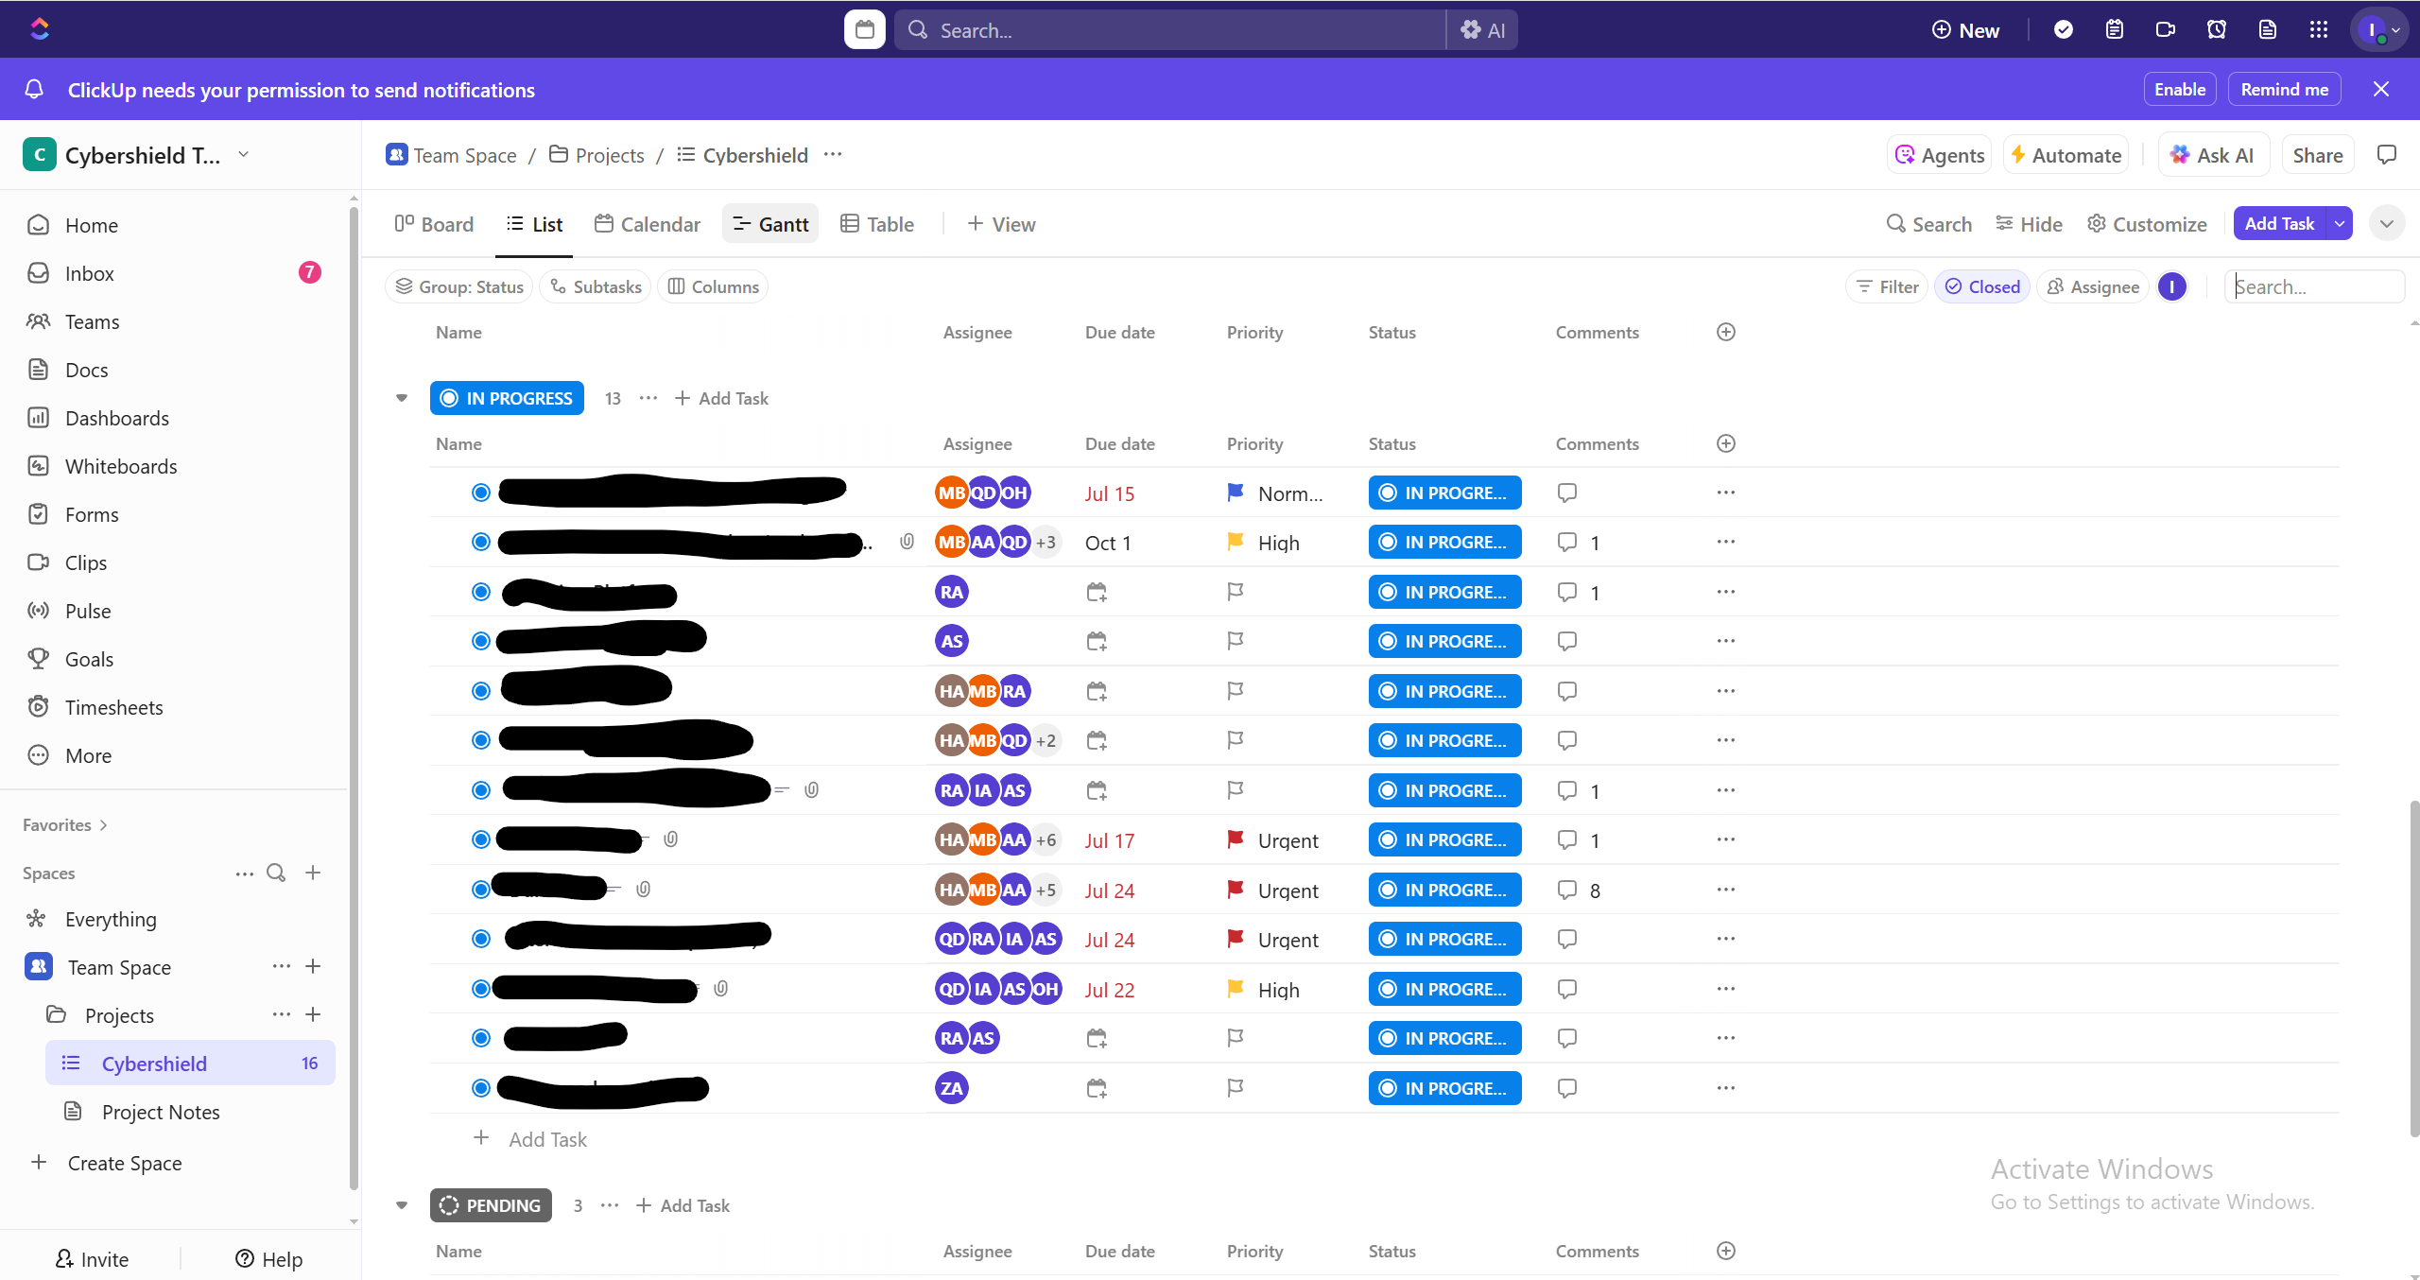
CPTS achievements until now:
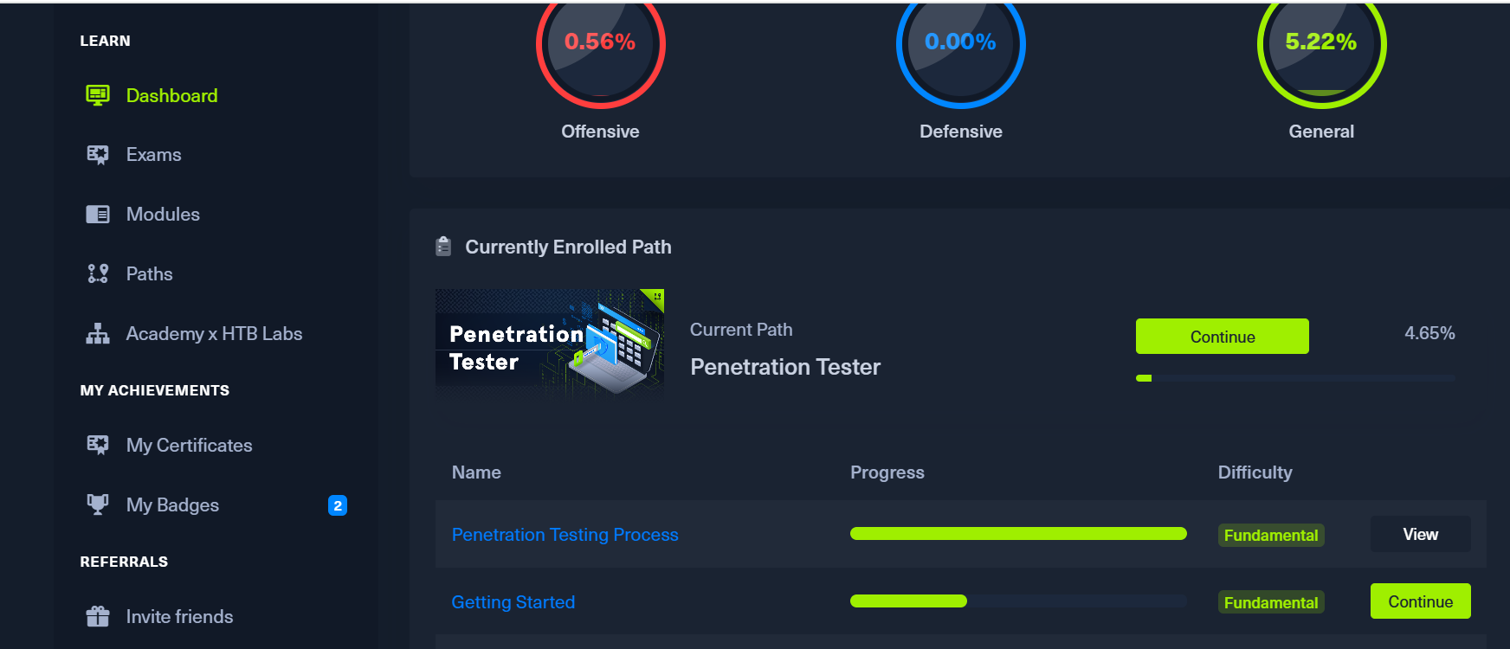

- Any problems/challenges, and how did you overcome them?
- I have a problem which is the lake of the information of some tasks that make me feel confused and don’t know what to do or the reason why that task get done for.
- Any training courses you attended during the apprenticeship, whether you opted for them independently or through the employer.
  - Name of the course: JODDB upskilling
  - Main Topics: penetration testing and forensics
  - Copy of certification: I didn’t take one (I started my training they were started with the course before 1/7/2025).

  - Name of the course: CPTS
  - Main Topics: Penetration testing
  - Copy of certification: in progress.

- What software/tools did you use?
- Kali Linux, Nmap, my Trello, Fortinet, gobuster, OpnSense, Vscode ,TOR browser ,Docker , CTFD, Microsoft Visio Hydra, Ubuntu, zeek, wazuh, Python, WSL , VMware, Twine, etc...
- Technical and non-technical skills
- Teamwork, Brain storming, Time Management, analytical thinking, writing CTF challenges ,Networking, planning ,Formatting and Booting, dealing the ISO and VM’s ,Ethernet Connections, Firewall Configuration, multi-tasking ,VPN, SIEM solutions, Docker, TTX, documentation .
- Did you work on the National Occupational Standards (NOSs)?
  - How many NOSs did you complete out of 5? 0/5
  - List of NOSs (Number (URN) – Name of NOS):

- Events/Conferences you participated
- Presenting the Capstone project in HTU expo career day.
- Your Plan for Next Month.
- In cyber shield every day we got a new task so there’s something new every day for any coming events that JODDB could host
- I am planning to got 4-5 modules of CPTS material.
- Starting work on my Capstone project and improve it.
- Developing my Blockchain project.

